**Experiment No. 04**

* 1. **Experiment Name**

Study of R-2R ADC & generation of different signals using Arduino microcontroller & designing PLL block

* 1. **Objectives**
* To get a better understanding of R-2R ADC Circuit
* To understand the function of R-2R ADC using an Arduino Uno
* To get familiar with the generation of different signals using Arduino Uno
  1. **Theory**

A Digital to Analog Converter (DAC) serves to transform digital signals into corresponding analog signals, while an Analog-to-Digital Converter (ADC) does the opposite. DAC finds applications in various fields, including audio, video, mechanical, and communication, with a primary focus on audio applications. The effectiveness of a DAC is evaluated based on parameters such as resolution and sampling frequency, and various DAC architectures exist. In this project, the R-2R Ladder DAC, known for its simplicity and versatility, is explored. Utilizing only two resistor values, it can be extended to any bit number, maintaining a consistent output impedance of R, simplifying filtering and circuit design.

On a different note, a Phase-Locked Loop (PLL) is a closed-loop feedback control system extensively used in electronics for diverse applications. Its principal function is to generate an output signal synchronized with the phase of an input signal, typically referred to as the reference signal, in various electronic systems.

* 1. **Apparatus**
* Arduino Uno (for ATmega328 microcontroller)
* Oscilloscope
* Resister (1kΩ; 24 pcs)
* Jumper wires
* Laptop
* Power supply
  1. **Connection diagram**
     1. **Experimental connection of R-2R ADC**

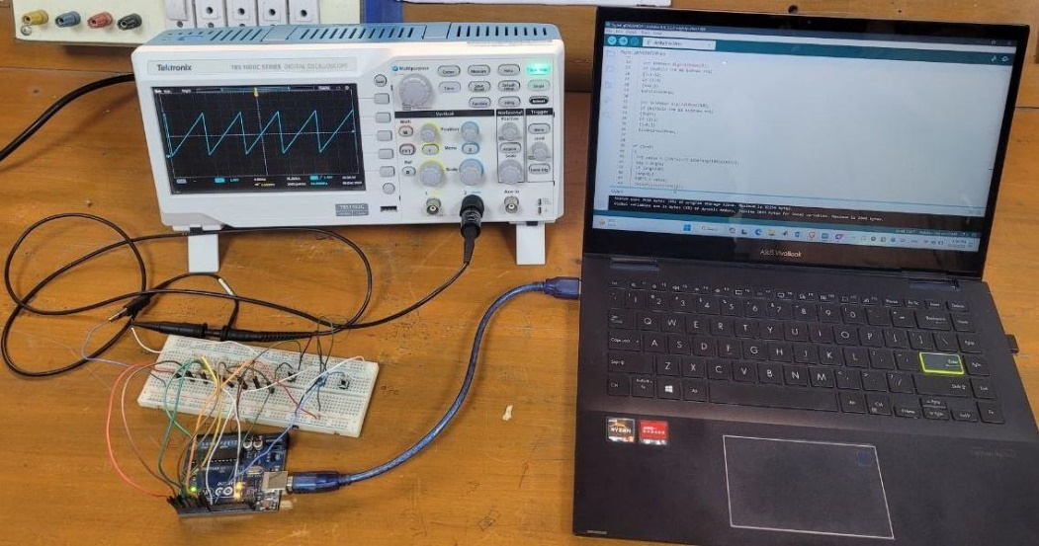

**Fig. 4.1:** Experimental setup of R-2R ADC

* + 1. **Experimental connection of PLL**



**Fig. 4.2:** Experimental setup of PLL

* 1. **Waveform**

**4.6.1 R-2R ADC Waveform**

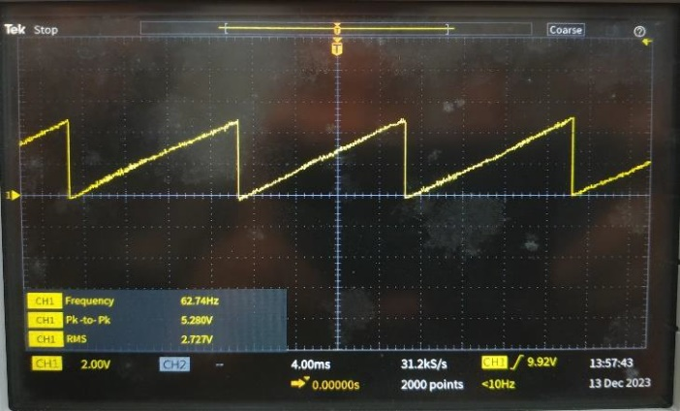 

**Fig. 4.3:** Sawtooth waveform **Fig. 4.4:** Triangular waveform

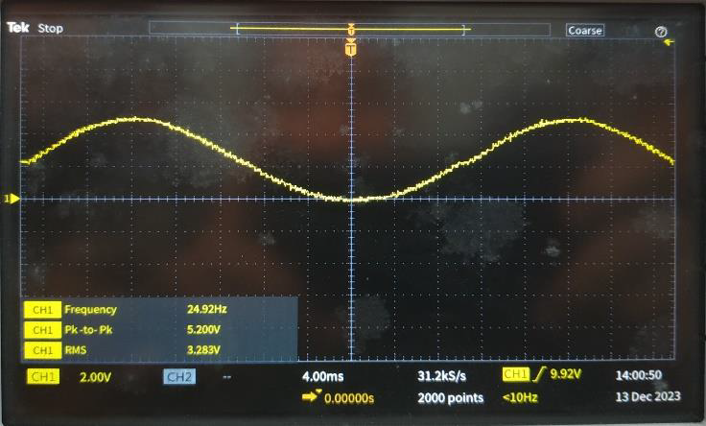

**Fig. 4.5:** Sinusoidal waveform

**4.6.2 PLC Waveform**



**Fig. 4.6:** Triangular signal representing the phase of the sinusoidal wave

* 1. **Discussion & Conclusion**

In this experiment, we successfully carried out the generation of different signals using an Arduino Uno designing PLL block and carried out an comprehensive study on R-2R ADC. Our approach involved meticulous programming of the Arduino Uno to align with the experimental requirements.

In this experiment, an Arduino-based function generator was constructed using an R-2R ADC circuit, generating sawtooth, triangular, and sinusoidal signals as depicted in figures 4.3, 4.4, and 4.5, respectively. In the subsequent phase of the experiment, a Phase-Locked Loop (PLL) was successfully implemented to accurately read the phase of a sinusoidal signal, as evident in figure 4.6. The overall experiment proved to be successful and yielded fruitful results.